Assignment 1: The Army Ant System  
By James Roose (100852693) and Eric Adamski (100873833)

**Introduction**:

The Army Ant system is a model of the way ants forage for food, and clearly displays the power of stigmergy. Although the model we have developed is imperfect, we can still gather a general concept of the way stigmergy works and the impact it has on both natural and artificial systems. This report will outline the observations and results we have gathered from our system.

**Our System**:

The purpose of this section is to outline how our system might differ from the classic army ant system and discuss flaws we feel could be improved upon in further iterations of the system. It will also briefly go over the system's most important variables.

Pheromone Variables:

* pheromone_to_nest: The amount of pheromone the ants drop after they've found food and are heading back to the nest.
* pheromone_from_nest: The amount of pheromone the ants drop when they are just exploring.
* evaporation_rate: How quickly the dropped pheromones dissipate.

Food Variables:

* food_density: Controls how close together the food nodes will be placed.
* food_amount: The number of food nodes that will be generated.
* food_conc: The number of times an ant can collect food from a food node before the node is exhausted.
* foodx: The x-coordinate marking the center of where the food will be spawned.
* foody: The y-coordinate marking the center of where the food will be spawned.

Ant Variables:

* num_ants: The number of ants in the system.
* n: The degree of non-linearity in the system.
* k: The degree of attraction of unmarked branches.

How our system could be better:

While developing our system, we struggled to achieve a foraging pattern that closely resembled that of the classic army ant system. Our biggest problem was preventing the ants from grouping. When the system is started, a huge number of ants all spawn in the same location. When they start moving forward, each ant will drop a small amount of pheromone. However, because there are so many ants in the same location, this often results in a large amount of pheromone being placed in one area. This makes the area irresistible to other ants, and causes a large group to form. Figure 1.0b outlines how a large amount of ants is actually not very good at foraging in our system.

Our system could have handled this better. In hindsight, there are a few solutions we feel may have helped the issue.

1. **Limit ants per patch**. Perhaps if the number of ants allowed on each patch were limited to some value, the ants would be less capable of grouping up.
2. **Stagger the release of ants**. If the spawning of ants were staggered to a set value per tick, up to the value of num_ants, rather than spawning all at once, we may not have seen as much grouping when the system is first started.

Another feature that could have been done better is the ants’ ability to find their way back home. Currently, the ants rely purely on pheromones to find their way home. This makes sense, because in real life, ants probably have to rely on pheromones to get home. However, this system is flawed. Occasionally, the ants get lost on their way home, usually when there isn’t enough pheromone leading the way. Our system currently deals with this by simply killing the ant. This solution also makes sense to us; if an ant gets lost, it dies.

Unfortunately, this solution can sometimes be disastrous. Ants that are carrying food leave a large trail of pheromone, so if an ant with food gets lost, it leaves behind a trail that other ants might follow to their death. If this trail gets too heavily reinforced, it’s possible for all of the ants to die. There are a few ways we could prevent this in future iterations of the system.

1. **Ants could remember the path they took**. This solution would ensure that every ant always makes it home.
2. **Pheromones_from_nest could be increased**. However, this solution heavily impacts the other mechanisms of our system and causes a large amount of grouping.
3. **Ants could remember the coordinates of the nest**. Although this solution would work, it seems like an unrealistic solution for a natural system.

These two issues are the main flaws we see in our system. Despite these flaws, however, we are still satisfied with its performance.

**Questions**:

1) When does the characteristic foraging pattern break down?

In our system, we found it difficult to accurately achieve the characteristic foraging pattern. Despite this, we can still see what kind of environment allows us to most closely represent it, as well as what kind of environment moves away from it. We observed that there might be a few reasons for the breaking down of the foraging pattern.

One reason the pattern might fail to hold is related to the amount of pheromone the ants drop when moving to and from the nest. For example, if ants are dropping 50 units of pheromone while exploring, but only 1 unit of pheromone after they've found food, the foraging pattern breaks apart. This is because the useful information, the location of the food, is being drowned out by the less useful information, where the ants are exploring. We noticed the amount of pheromones ants drop when coming from the nest in search of food was particularly important in ensuring the ants properly forage for food.

Another important factor is the number of ants in the system. When a large amount of ants are grouped, they tend to bunch up and drop a ton of pheromones on a certain path. It becomes difficult for the ants to break from the pack and explore due to this large amount of pheromones being dropped while the pack of ants explores. Even if the pheromone_from_nest variable is extremely low, 3000 ants dropping even one pheromone each in the same location once again drowns out the information the ants need to find food.

Lastly, the values of n and k can impact the foraging pattern, where n makes the movement of the ants much more linear and k makes the ants more willing to explore unexplored areas, causing a bigger spread.

Ultimately, it comes down to the placement and amount of pheromones. Even attributes such as the evaporation rate can impact the foraging pattern. If pheromones don't properly lead the way to the food, the pattern will break down. Below are some examples of pattern changes in our system due to the reasons listed above.

Figure 1.0

.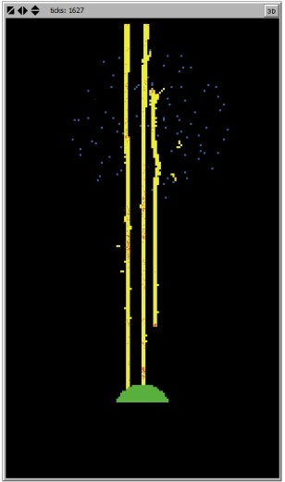 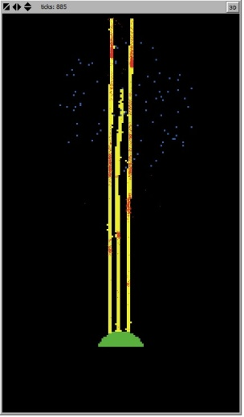 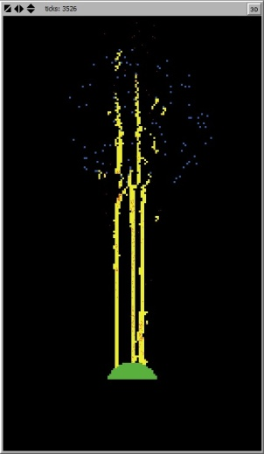 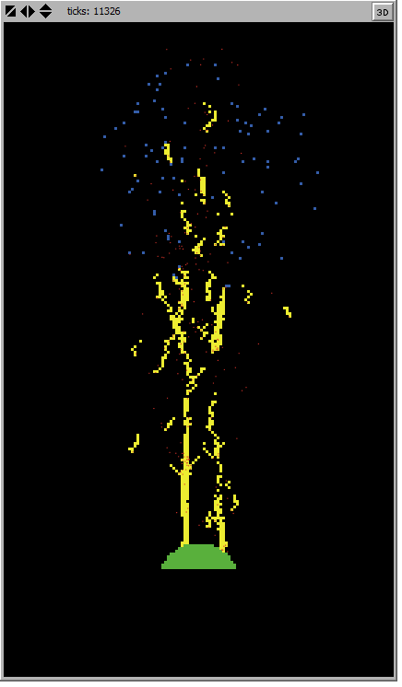  
 a) pheromone_from_nest = 15 b) num_ants = 3000 c) n = 30 d) k = 80

2) Comment on the relationship between food density and foraging efficiency.

In our system, the relationship between food density and foraging efficiency was very strong. The more densely the food was distributed, the more efficient the ants were at foraging. The table below clearly presents a strong relationship between the food density and the number of food nodes the ants discovered.

Figure 1.1

|  |  |  |
| --- | --- | --- |
| Trial # | Food Density | Food Nodes Discovered |
| 1 | 25 | 42 |
| 2 | 25 | 41 |
| 3 | 25 | 52 |
| 4 | 25 | 40 |
| 5 | 25 | 50 |
| 6 | 75 | 99 |
| 7 | 75 | 90 |
| 8 | 75 | 95 |
| 9 | 75 | 96 |
| 10 | 75 | 92 |

Each test allowed 250 ants to forage for 10000 ticks. Five trials were run with a food density of 25 and another five were run with a food density of 75. Although the results vary, due to the random nature of the ants' movement and the food distribution, the results are most certainly statistically significant. The ants, on average, discovered only 45 out of a possible 100 nodes when the food density was set to 25. However, at a food density of 75, the ants, on average, discovered 94 out of a possible 100 nodes. The difference is clear and we can conclude that there exists a strong relationship between food density and foraging efficiency.

3) How does the behaviour of the system vary with changing n and k?

When the values of n and k were changed, our system changed significantly. Increasing the value of n increases the linearity of the system; meanwhile increasing the value of k increases the ants' attraction to unmarked branches. As a result, large values of n lead to larger groupings of ants and large values of k lead to a larger spread. This effect is shown in Figure 1.0c and Figure 1.0d. For our system particularly, we found larger values of k were preferable because we had already encountered problems with too much grouping, preventing the characteristic foraging pattern from immerging.

The chart below describes how larger values of k can improve the ants' foraging by causing a greater spread. With a greater spread, ants are more likely to discover more nodes of food. Each experiment displays the number of food nodes discovered after the first 2500 ticks with varying values of k.  
  
  
  
Figure 1.2

|  |  |  |
| --- | --- | --- |
| Trial # | k value | Food Nodes Discovered |
| 1 | 5 | 38 |
| 2 | 5 | 36 |
| 3 | 5 | 36 |
| 4 | 10 | 40 |
| 5 | 10 | 45 |
| 6 | 10 | 46 |
| 7 | 25 | 58 |
| 8 | 25 | 52 |
| 9 | 25 | 53 |

Tukey HSD Test:

|  |  |  |  |
| --- | --- | --- | --- |
|  | k = 5 | k = 10 | k = 25 |
| Mean | 36.6 | 43.6 | 54.3 |
| N (# of trials) | 3 | 3 | 3 |
|  |  | MSerror = 7.3333 | dferror = 6 |

k = 5 vs. k = 10 🡪 P < 0.05  
k = 5 vs. k = 25 🡪 P < 0.01  
k = 10 vs. k = 25 🡪 P < 0.01 Therefore, results are statistically significant.